## Nathan Chuluda

CS-340-T3703 Client/Server Development 22EW3

Project 2 README

February 11, 2022

## **About the Project/Project Title**

Grazioso Salvare Animal Rescue Dashboard

## **Motivation**

Grazioso Salvare trains search and rescue dogs, and needed to simplify their animal acquisition process. By teaming with local animal shelters in the Austin, Texas area, a database of available rescue dogs has been made accessible to the client. This Dashboard serves as an interface for Grazioso Salvare employees to use when searching for candidates to recruit as rescue dogs. There are 3 categories of rescue animals that Grazioso Salvare trains. These have been attributed to radio buttons that allow the user to filter the entire database so only suitable breed, sex and age animals are displayed. A pie chart updates to show the percentage of each breed displayed on each page. By selecting a single row, the map will update with a pin dropped at the location where the animal was originally found.

## **Getting Started**

To get started, have a MongoDB server running with at least one database and user account created. Update the .ipynb file to reflect the correct server and login credentials.

**Tools Used:**

MongoDBis used for the database component of this project. Additional frameworks have been used to increase functionality and create an intuitive user interface. PyMongo is used for the CRUD operations that connect the database to the front end. Dash is used to clearly format the data so that it is well presented to the user. Plotly express is used to visualize the data presented to the user.

**https://www.mongodb.com**

**https://pymongo.readthedocs.io/en/stable/**

**https://plotly.com/dash/**

**https://plotly.com/python/plotly-express/**

**https://numpy.org**

**https://pandas.pydata.org**

Page loads to default setting that displays all animals in the database:

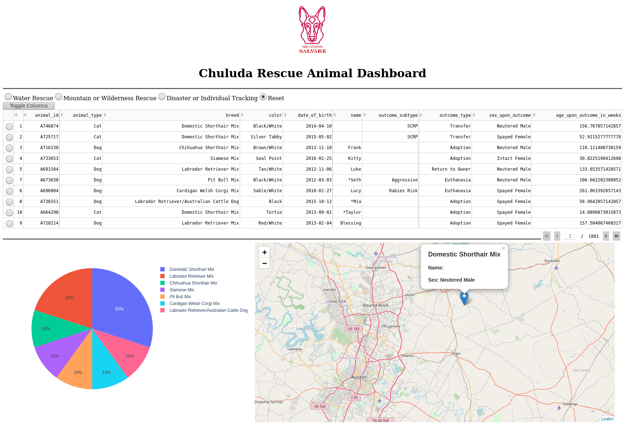

Search results filtered to show potential Water Rescue dogs:

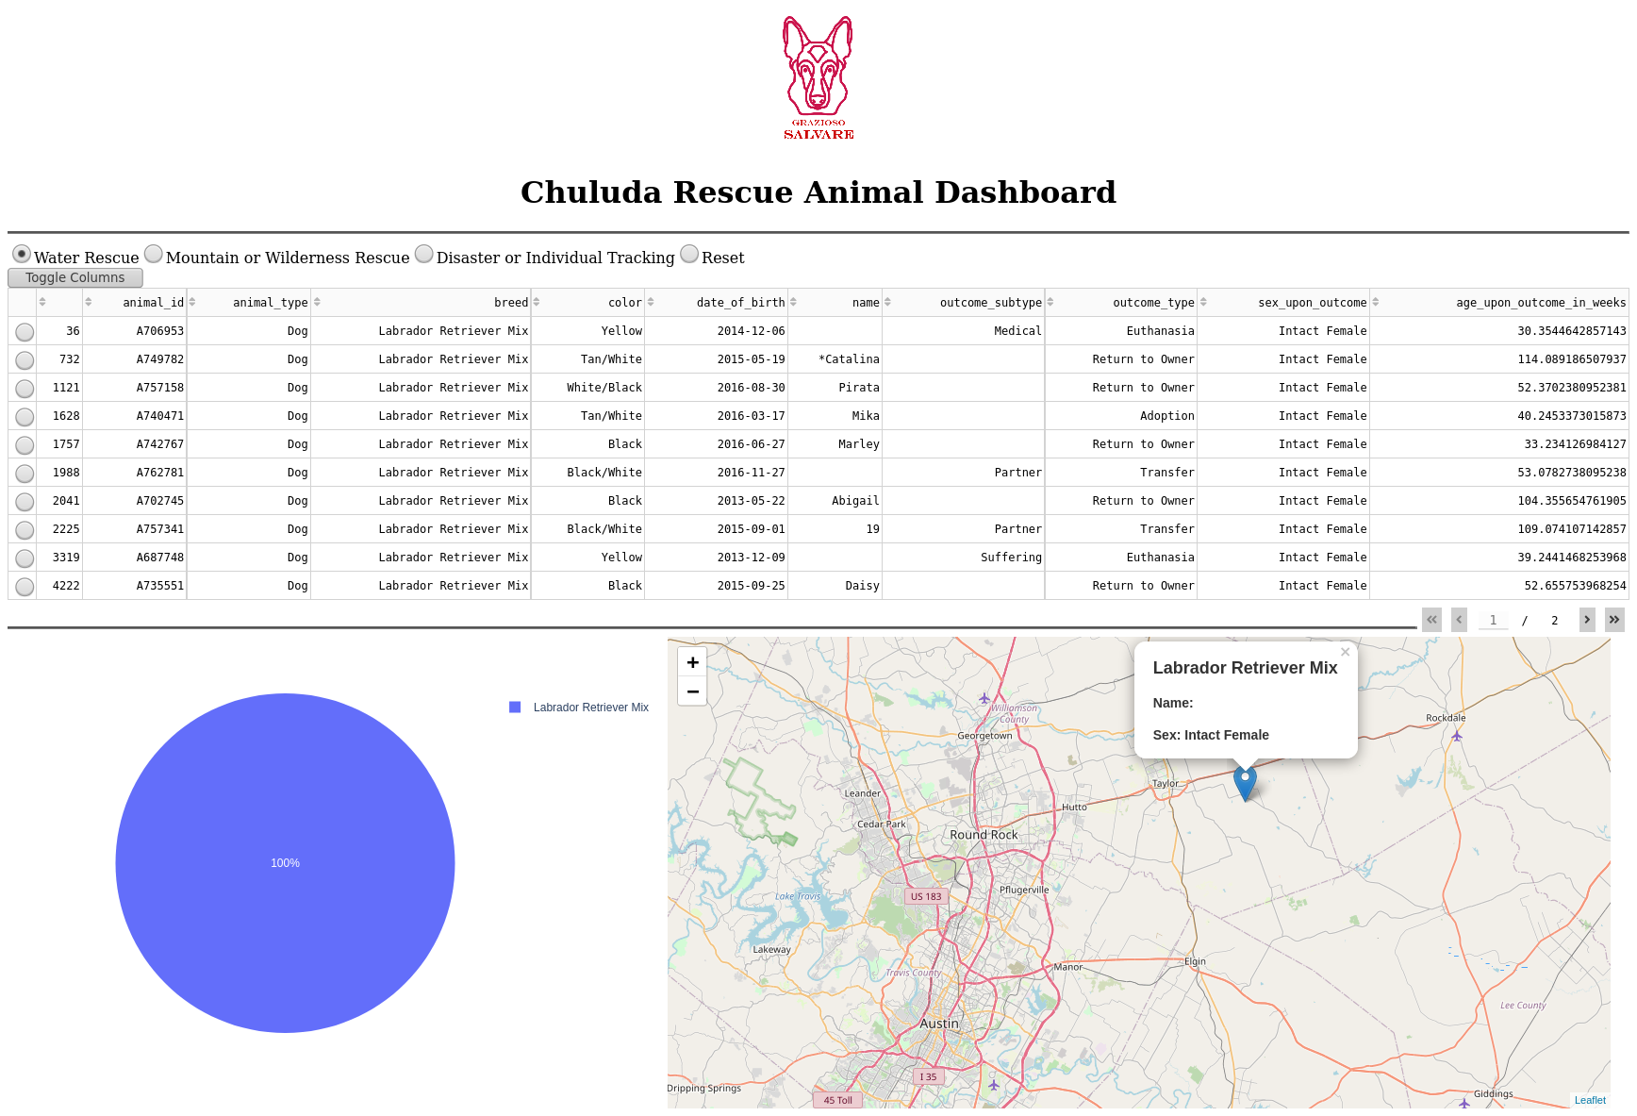

Search results filtered to show potential Mountain or Wilderness Rescue dogs:

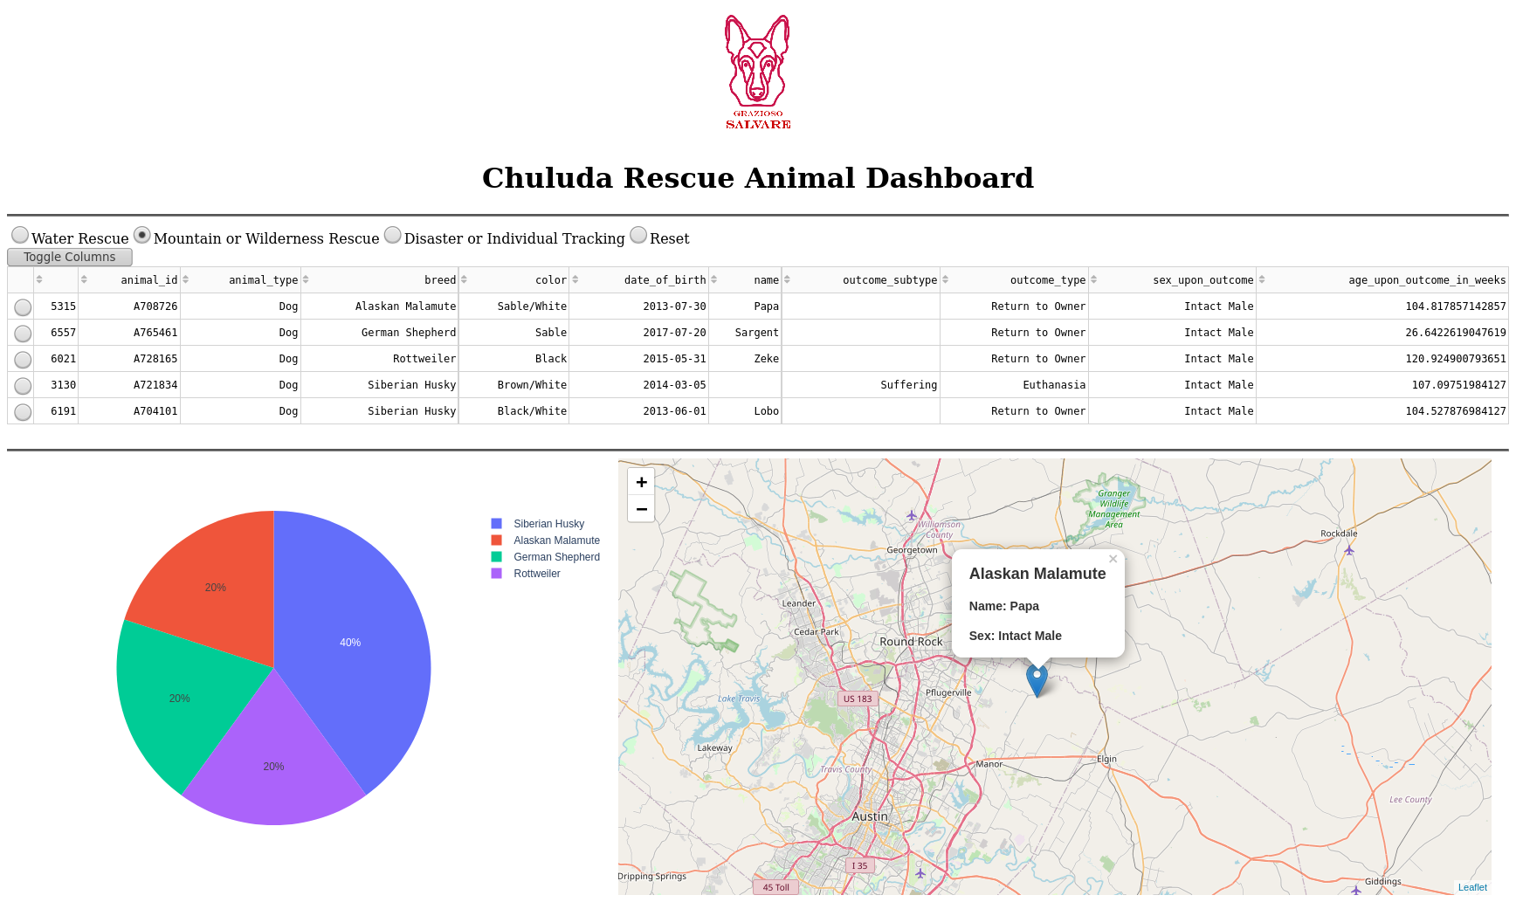

Search results filtered to show potential Disaster Rescue or Individual Tracking dogs:

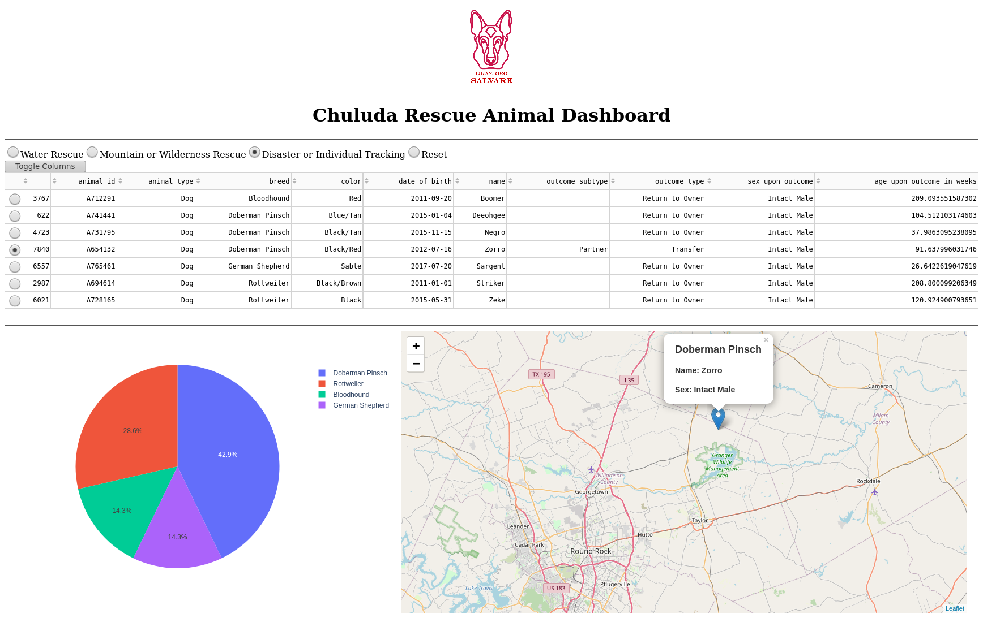

Map updates to reflect location of animal when a single row is selected:

